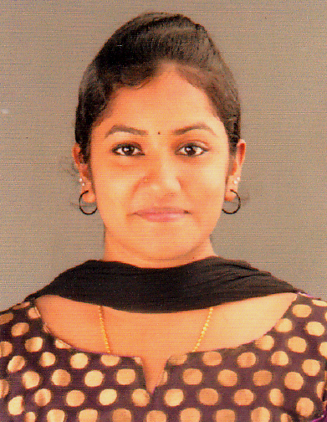

**Ruby P Jacob**

**Elanjickal (H), Piralassery P.O**

**Chengannur, Alappuzha, Kerala**

**+91-8921147613**

**rubypjacob02@gmail.com**

**PHYSIOTHERAPIST**

OBJECTIVE: To work with a center of therapy that give a chance to improve knowledge and skills as a physiotherapist and climb up the ladder of success along with taking my organization to height of Popularity and Respect.

**ACADEMIC/ PROFESSIONAL QUALIFICATIONS:**

* **S.S.L.C – Metropolitan Higher Secondary School, Puthecavu**
* **H.S.C – Vocational Higher Secondary School, Aranmula**
* **Bachelors in PHYSIOTHERAPY – Alva’s College of Physiotherapy, Mangalore**

**INTERNSHIP**

* **Orthopedic Exposure in : TEJASWINI Hospital (ICU, Post-Operative Department)**
* **Neurology & Neurosurgery in: First Neuro Hospital and Mallikhatte Neuro Center, Mangalore**
* **Orthopedics and Sports Rehabilitation : Alva’s College of Physiotherapy**
* **Community based Rehabilitation and Geriatrics**
* **Emergency/ Casualty Department: Alva’s Health Center**
* **Neuro-Physiotherapy and Rehabilitation: Alva’s College of Physiotherapy**
* **Cardio-Respiratory**
* **Neuro-Pediatric Department: Alva’s College of Physiotherapy**

**CERTIFICATIONS**

* **Certification in Indian Academy of Fitness Training in Pre & Postnatal Instructor**
* **Certification in Indian Academy of Fitness Training in Diet & Nutrition Instructor**
* **Certification in Indian Academy of Fitness Training in Aerobics Instructor**
* **Certification in Indian Academy of Fitness Training in Primary and Advanced Pilates Instructor**
* **Certification in Indian Academy of Fitness Training**
* **Certification in Indian Academy of Fitness Training in Advanced Gym/ Fitness Instructor**
* **Certification in National Conference “ RECENT DEVELOPMENT IN ORTHPEDIC SURGERIES & UPDATE IN REHABILITATION & RESEARCH”**

**WORKSHOPS**

* **Basics of Manual Therapy**
* **Two Dimensional Video Analysis and Science of strength training in sports-practical demo**

**PRESENTATIONS**

* **“Frontal Plane Analysis of Gait” : Alva’s College of Physiotherapy**
* **“ Phases of Pulmonary Rehabilitation” : Alva’s College of Physiotherapy**

**KEY SKILLS & STRENGTHS:**

* Ability to manage risks & issues
* Experience in dealing with Emotional and Stressful situations
* Ability to motivate others through effective communication skills
* Awareness in Fire, Health & Safety and Departmental Policies
* Organizing and prioritizing own workload & delegating responsibilities accordingly
* Ensuring that the equipment’s used in carrying out Physiotherapy procedures are safe
* Involvement in ward rounds, meeting and conferences
* Prioritizing urgent referrals and emergency cases
* Excellent oral and written Communication skills

**HOBBIES:**

* Singing, Dancing, Yoga, Hand-crafts, Badminton

**PERSONAL INFORMATION**

**Date of Birth:** 24thMarch, 1994

**Marital Status:** Single

**Nationality:** Indian

**Sex:** Female

**Relegion:** Christian

**Languages Known:** English, Hindi, Tamil, Kannada, Malayalam

**DECLARATION:**

I hope you will find my experiences suitable for your esteemed organization and if given an opportunity, I will put all my efforts to work hard in serving the organization and in gaining knowledge.

Thanking you,

**Ruby P Jacob**

**+91-8921147613**